Lab Guide for MS Word







Author(s) | Rekha T S
Authorized by
Creation/Revision Date
Version

COPYRIGHT NOTICE

All ideas and information contained in this document are the intellectual property of Education and Research Department, Infosys Technologies Limited. This document is not for general distribution and is meant for use only for the person they are specifically issued to. This document shall not be loaned to anyone, within or outside Infosys, including its customers. Copying or unauthorized distribution of this document, in any form or means including electronic, mechanical, photocopying or otherwise is illegal.

Education and Research Department
Infosys Technologies Limited
Electronics City
Hosur Road
Bangalore - 561 229, India.

Tel: 91 80 852 0261-270
Fax: 91 80 852 0362
www.infy.com
mailto:E&R@infy.com

Document Revision History

Version | Date | Author(s) | Reviewer(s) | Comments
1.0 |  |  |  | Initial Draft
2.0

Contents

COPYRIGHT NOTICE ii
Document Revision History i
Contents ii
Context 1
1. MS Word Primer 1
1.1 Basic File Options 2
1.1.1 Opening the Document 2
1.1.2 Saving Documents 3
1.1.3 Copy, Cut and Paste 3
1.2 Formatting the Text 3
1.2.1 Changing the Font style 4
1.2.2 Aligning the Text 4
1.2.3 Bulleted and Numbered Lists 4
1.3 Spelling and Grammar 4
1.4 Auto Correct option 5
2 Edit option in Word Document 7
2.1 Undo & Redo Options 7
2.2 Find & Replace 8
2.3 Bookmark & Go to Options 9
2.4 Format Painter 10
2.5 Inserting Pictures & Objects 10
3 References 11
3.1 Inserting Footnotes & End Notes 11
3.2 Hyperlinks 12
3.3 Table of Contents (TOC) 14
4 Page Layout 17
4.1 Page, Line & Column Breaks 17
4.2 Header & Footer 19
4.3 Watermarks 19
5 Reviewing Features 20
5.1 Comments 20
5.2 Track Changes 20
5.3 Protecting the Document 21
6 Tables 22
7 Mail Merge 26
8 Envelopes and Labels 29
9 Printing the Word Document 30

Context
This document contains step by step Lab guide on the usage of MS Word 2007

Note: All assignments in this document must be completed in the sequence in this document in order to complete the course. It is advisable to study & practice the examples incorporated in the Slides before starting with the below assignments/exercises.

Objective: To learn about using MS word.

Background: MS Word is a powerful general purpose, word processing program that can be used to create basic documents of all kinds of letters, memos, reports, charts, resumes etc. The following steps will help you to learn the various features of Ms Word 2007.

1. MS Word Primer
To Open a Word Document,

Click on start → All Programs → Microsoft Office → Microsoft Office Word 2007

Screen Layout
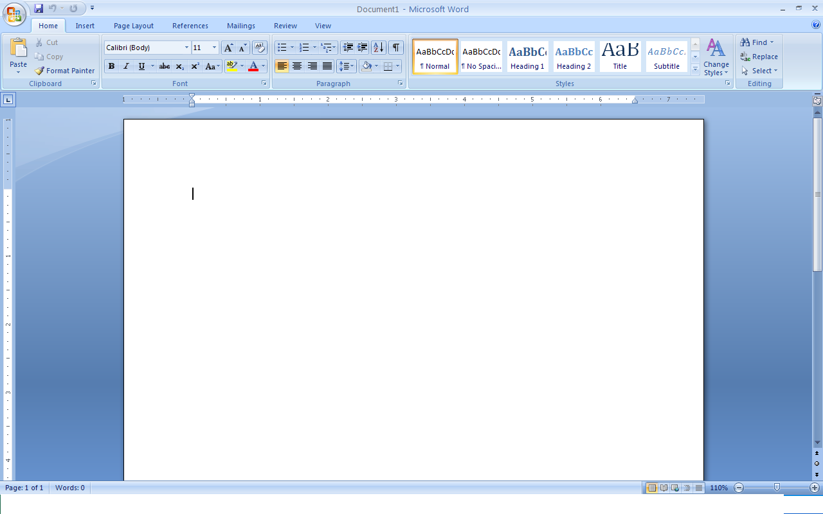
2
5
4
3
1
Description of the Screen Layout
- Title Bar: States the Title of the Word document. Default title is “Document 1”
- Status Bar: Gives the following information about the document
    - Current page
    - Total pages in the document
    - Total Word Count
- Text Area: Area where you type the text / edit the document
- Scroll bar: Helps you to navigate through the document
- The Ribbon: Used for quick access of access
- The Ribbon is divided into eight tabs by default and each tab is geared towards a certain activity area.

1.1 Basic File Options

Opening the Document

- Click on the Office Button at the top left corner of Word document
- Select New for opening a new word document
- Select Open for opening an existing document

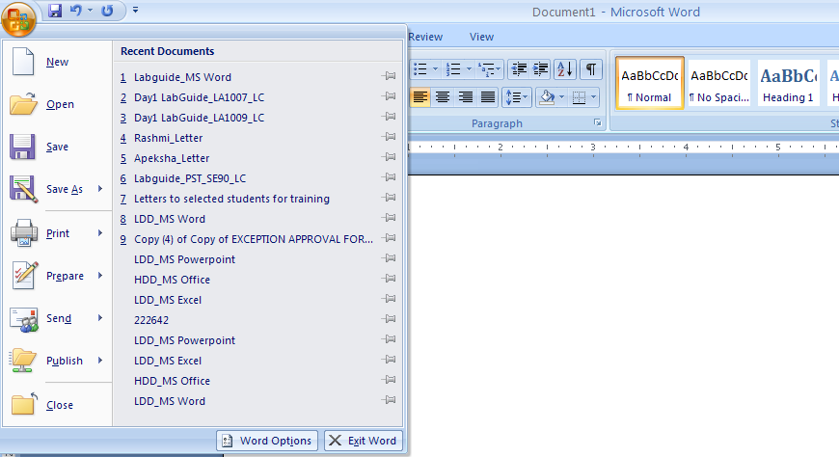

Saving Documents
- Click on the Office Button at the top left corner of Word document
- Select Save for saving the document
- Browse the location where the file has to be saved
- Click on the Save button
- Save As option is used, if the document is needed to be renamed / saved in different location
  - Save As option is also used if a document need to be saved in different versions of Word
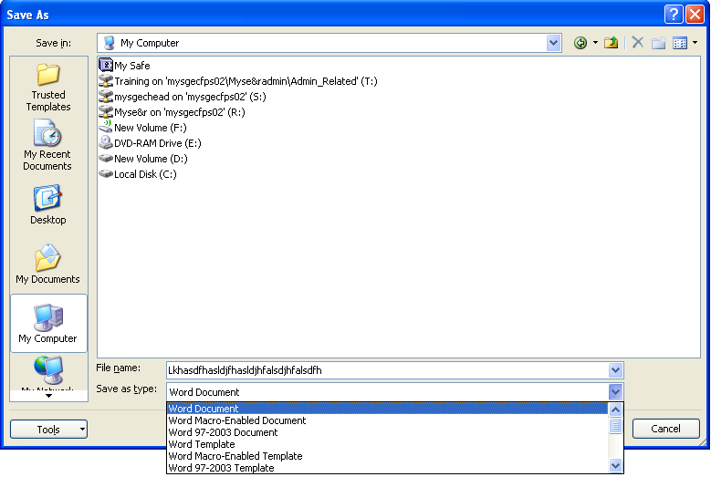

Copy, Cut and Paste
Steps to be followed,
- Select the text to be copied / cut
- Click on Home tab
- Select Copy / Cut option
- Go to the destination & click on Paste

Formatting the Text

Changing the Font style
- Highlight the entire text
- Click on the Home tab
- Click on the Font option to change the font style, size, color, highlighting the text etc
- To change the case of the text (upper case / lower case) click this option in Home Tab →
- To change the text to superscript, click this option →
- To change the text to subscript , click this option →

Aligning the Text
- Highlight the entire text
- Click on the Home tab
- Go to paragraph option
- Select the desired alignment option

Bulleted and Numbered Lists
One of the smart features of the word is to create the numbered lists. Word can automatically assign the consecutive numbers to the list of items separated by enter key.
- Click on the Home tab
- Go to paragraph option
- Select either the Bullets option or Numbering Option based on the requirement

Spelling and Grammar
Word will automatically check for spelling and grammar errors as we type. Spelling errors are noted in the document with a red underline. Grammar errors are indicated by a green underline. To use the spelling and grammar checker, follow these steps:
- Highlight the text
- Select Review tab
- Click on spelling and Grammar option in Proofing tab
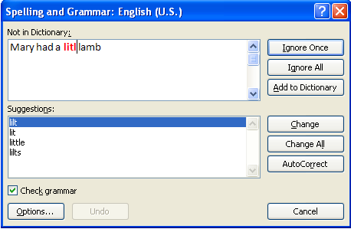
- If the word is spelled correctly, click the Ignore button or click the Ignore All button if the word appears more than once in the document.
- If the word is spelled incorrectly, choose one of the the suggested spellings in the Suggestions box and click the Change button or Change All button to correct all occurrences of the word in the document.

Auto Correct option
MS Word automatically correct the misspell words & incorrect capitalization as you type. Auto correct feature is used to perform this task.
For example, if you type teh plus a space, then AutoCorrect replaces what you have typed with “the.” Or if you type This is 6he house plus a space, AutoCorrect replaces what you have typed with “This is the house.”
Steps to use Auto Correct feature,
- Click on Office Button
- Click on Word Option
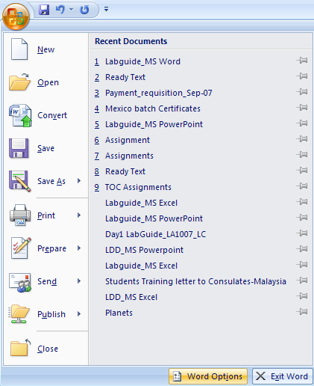
- Click on Proofing
- Click on Auto Correct
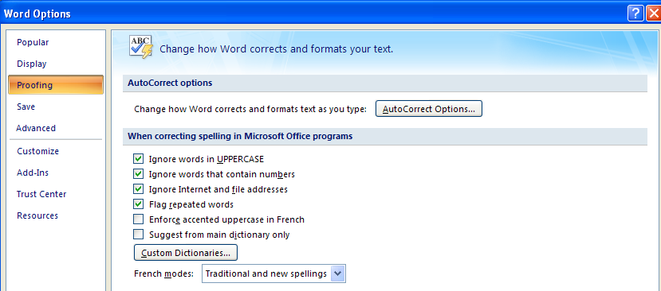
- In the below snapshot, you are adding a new word to the auto correction. When you type CT and hit space, document automatically corrects that word to CTY
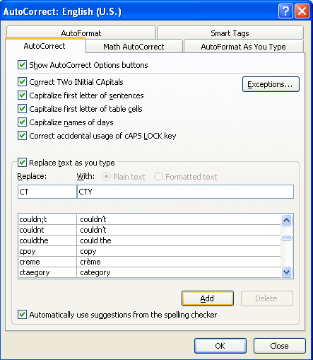

Edit option in Word Document

Undo & Redo Options
Word displays list of actions that can be undone when not required.
- Click on Undo button on the Quick Access Toolbar to cancel the latest action.
- Click on the drop down arrow key to display a list of actions that can be undone to undo a certain action.
- Click on Redo button next to Undo button if you didn’t want to undo an action.

Find & Replace
Word provides an option to replace text, formatting, paragraph marks etc. Also wildcards can be made use of for searching.

- Click on Home tab
- Select Editing group
- Click Find
- In the Find What box, enter the text that you want to search for.
- Select any other options that you need
- Click Find Next to continue or Find All for all occurrences

Word automatically lets you to replace text or phrase, character formatting etc.
Note: It is Case sensitive.

- Click on Home tab
- Select Editing group
- Click Replace enter the text to replace
- In the Find What box, enter the text that you want to search for; or if you are searching formatting only leave the box blank
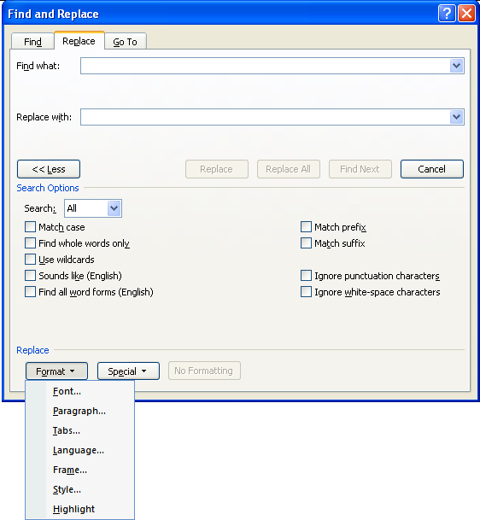
- Click Format, and then select the required formatting options.

Note: Use the asterisk (*) wildcard to search for a string of characters (Fox Example "s*d" finds "salad" and "started").

Assignment on Find & Replace option: From the attached text below, fine the word “calcium” (highlighted with bold letters) and replace it with Calcium (highlight with red color, bold and italics)
Click here for Assignment → 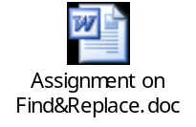

Bookmark & Go to Options
A bookmark created and placed identifies a location or a selection of text that you name and identify for future Cross Reference. For example, instead of scrolling through, place bookmarks in places for easy identification at the later time.

Select an item or click where you want to insert a book mark
- Click Insert tab
- Click Bookmark in Links group
- Enter a name for Bookmark to be created
- Click Add

Go to a specific Bookmark:

- Click Insert tab
- Click Bookmark in Links group
- Click the name of the Bookmark that you want to Go To
You can also add cross-references to bookmarks. For example, after you add a bookmark in a document, you can refer to that bookmark from other places in the text by creating cross references to the bookmark.
Assignment on Bookmark: From the below attached text, create a bookmark for the texts (Page 1 & Page 4) – as mentioned in the attachment
Click here for Assignment → 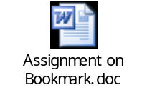
To create a Cross Reference:
- Click the location where you want to insert bookmark
- Click Insert tab
- Click Cross-reference in Links group
- Select Bookmark under Reference Type
- Click the name of the Bookmark that you want to insert from For which bookmark
- Click Insert button

Format Painter
You can use Format Painter on the Home tab to apply text formatting and some basic graphics formatting, such as borders and fills.

- Select the text, paragraph or graphics that has the formatting that you want to copy.
- Click Home tab
- Click Format Painter which changes to paint brush icon, in the Clipboard group
- Select the content that you want to format
- Double-click the Format Painter button if you want to change the format of multiple selections in your document and continue selecting the content to format.
- To stop formatting, press Esc.

Inserting Pictures & Objects
Word allows us to insert pictures from several sources inclusive of websites, stored picture files etc.

- On the Insert tab, in the Illustrations group, click Picture.
- Search and locate the picture that you want to insert
- Click the picture that you want to insert

To insert an Object:

Object is information/content of other programs that can be accessed, through the program in use, if compatible.

Object can be inserted by 2 methods. Embedded & Linked Objects. Inserted Embedded objects do not get updated at the destination, whereas Linked objects will get updated whenever changes are made to the source file.

- Click in the document where you want to place the linked object or embedded object.
- On the Insert menu, click Object under Text group
- Click Create from file.
- In the File box, type the name of the file you want to create a linked object or embedded object from, or click Browse to select from a list.
- Check Link to File
- Check Place as Icon

Note: Next time when you open the file that contains linked object, below windows pops up prompting to update the file.

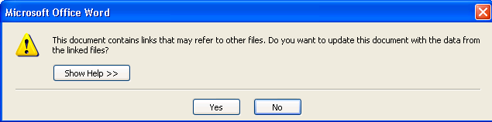

References

Inserting Footnotes & End Notes
Footnote: Consists of some supplementary text that is printed at the bottom of the page. Footnote reference marks would be inserted by selecting the footnote option. Word takes care of numbering the footnotes automatically. There can be several footnotes on one page.
Steps to create Footnotes,
- Select the word for which you need to insert a footnote
- Go to References Menu
- Click on “Insert Footnote”.
  - A footnote number format can also be changed by selecting the format option
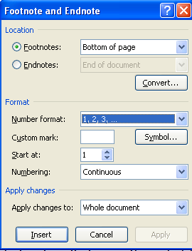
- When you get the cursor at the end of the page, insert a text

End Note: Is normally placed at the end of the document
Steps to create End notes are same as Footnote. Option to be chosen in Reference Menu is “Insert Endnote”
Assignment on Footnotes & End Notes:
- From the below attached text, find the synonyms for the words highlighted & underlined in blue color (Page 1), create footnotes for these words.
- From the below attached text, find the synonyms for the words highlighted & underlined in red color (Page 2), create endnotes for these words.
Click here for Assignment → 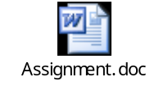
Note: To go Footnote or End note, click on the numbered option against a particular word in the document

Hyperlinks
Hyperlinks are created to browse through a piece of information either within a document or from the external file.
Hyperlinks can be created either to a Bookmark or a source to an external file
Steps to create a Hyperlink to a Bookmark
- Click on Insert Menu
- Select the text where you want to place the Hyperlink
- Select Hyperlink option
- Select Bookmark option
- Select the bookmark – which you have already created
- Click on Ok
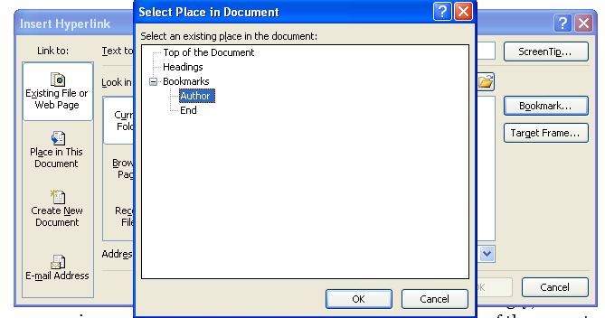
- The text on which Hyperlink is created would be highlighted with hand icon. By holding control click on the text to go the link
Steps to create a Hyperlink to an external source
- Step 1 to 3 to be repeated as mentioned above
- Click on Look in dialogue box
- Select the required file – as shown below
- Click on OK
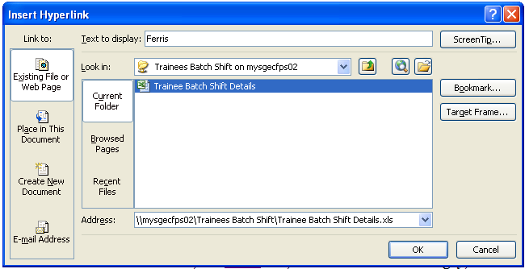
Assignment on Hyperlink: From the below attached file, create a Hyperlink for the texts, “Go to page 1” & Go to Page 4” based on the bookmarks created with the captions: Page1 & Page 2.
Click here for Assignment → 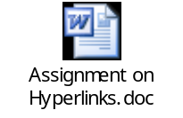

Table of Contents (TOC)
Table of Content (TOC) is created to provide a brief outline of the topics discussed in the document. This would help the reader to browse through the document easily
Better way to create TOC is by using Heading styles. For example Heading 1, Heading 2 etc based on the content of the document.
Steps to create Heading styles of the document,
- Select the text where you wish to be heading
- Click on Home Tab and go to the Style option
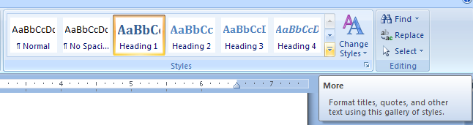
- Select the appropriate style
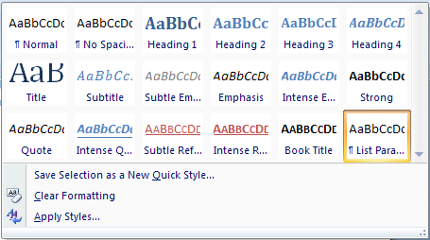
- Go to the destination where TOC needs to be placed
- Click on the References
- Go to Table of Contents
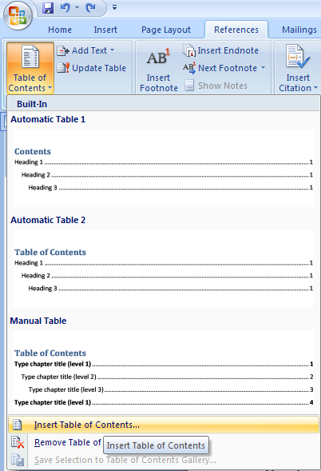
7. Click on Ok
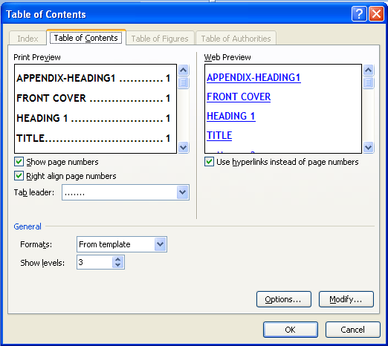
Click here for Assignment → 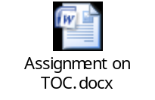

Page Layout

Page, Line & Column Breaks
To insert a manual Page Break:

- Click on Insert tab
- Click Page Break in Pages

If you insert manual page breaks in documents that are more than several pages in length, you might have to frequently re-break pages as you edit the document. To avoid the difficulty of manually re-breaking pages, you can set options to control where Word positions automatic page breaks.

- Widow/Orphan control Prevents Microsoft Word from printing the last line of a paragraph by itself at the top of a page (a widow) or the first line of a paragraph by itself at the bottom of a page (an orphan).
- Keep lines together Prevents a page break within a paragraph.
- Keep with next Prevents a page break between the selected paragraph and the following paragraph.
- Page break before Inserts a page break before the selected paragraph.
- Suppress line numbers Prevents line numbers from appearing next to selected paragraphs. This option does not affect documents or sections with no line numbers.
- Don't hyphenate Excludes a paragraph from automatic hyphenation.

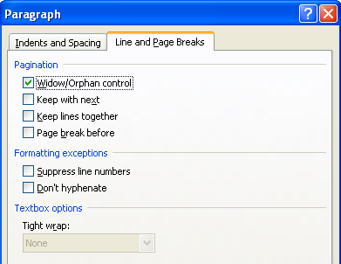

To insert Column Break
- Click where you want to start the new column.
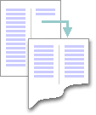
- Select Page Layout, click Breaks within Page Setup group
- Click Column

Header & Footer
Area within the margin is used to include Headers and Footers of each page in a document. You can include Company Logo, Company Name, Page number, Date etc., according to the requirement.
You can work in the header and footer areas by clicking Header and Footer on the Insert menu.
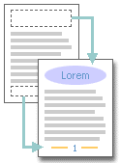
Insert same headers and footers for each page:
- Click Insert tab
- Click Headers or Footer on Header & Footer group
- Select the required type and sub-options

Assignment on Header & Footer: From the below attached file, create a Header with the caption: Assignment on MS Word 2007 and in Footer, attach Page nos & No. of pages (left aligned)

Click here for Assignment → 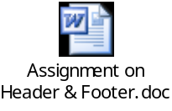

Watermarks
Watermarks are text or pictures that appear behind document text. They often add interest or identify the document status, such as marking a document as a Draft. You can see watermarks in Print Layout view and Full Screen Reading view or in a printed document.

Note: Watermarks can be viewed only in Print Layout and Full Screen Reading views and on the printed page.

- Click Page Layout tab
- Click Watermark in Page Background group
- Select one of the option OR
- Click on Customize watermark to include required watermark (Picture or Text)

Reviewing Features

Comments
Comments can be used if a small piece of information needs to be inserted on to a particular word or a line

Steps to insert a comment,
- Select a word or a line where the comment needs to be inserted
- Click on Review
- Click on New Comment and add your comment

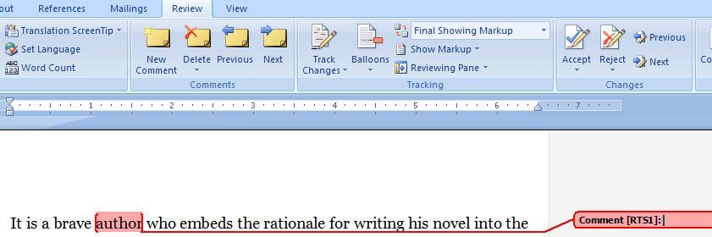

- Comment can also be deleted by using the Delete option

Track Changes
This option helps you to track the changes that you make to the document. Changes like Insertion, deletion and formatting can be tracked.

Steps to create Track changes in the document,
- Click on Review
- Go to Track Changes Option
- Click on Track Change

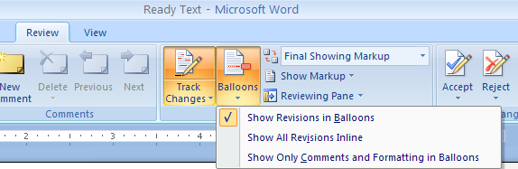

- Every change made to the documents would be highlighted in Red color
- Balloons shows the revisions made to the document
- Show Markup option shows the names of those people who have reviewed the document

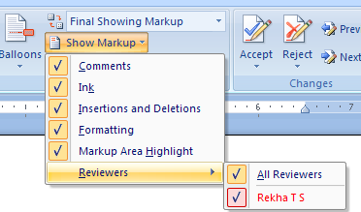

- Changes thus made can either be Accepted / Rejected by clicking on the appropriate option.

Protecting the Document
A document can be protected against any unwanted changes to be made. Restricted access can also be given to the reviewers

Steps to Protect the Document
- Click on Review
- Click on Protect Document
- Restrict Formatting & Editing options includes,
  - Formatting Restrictions which can be limited for the selected styles
  - Editing Restrictions which can be given to the Tracked changes / Comments / Filling forms / No changes
  - Users can be added
  - Click on the option – “Yes start Enforcing Protection”
  - Enter the password which would be optional.

Tables
Table option in MS Word allows you to insert or create a table to the document

Steps to insert a table to the document,
- Select Insert Menu
- Select Table option
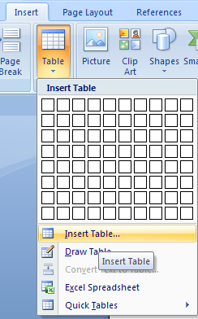

- Select No. of Rows and Columns and click on OK

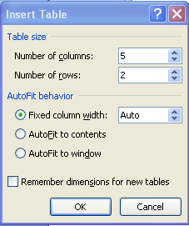

- Select the Table style of your choice
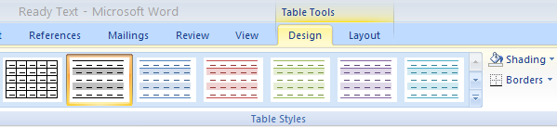

- Text that you enter in the column would be auto adjusted within the column
Best selling book of the year 2007 | Best Author of the year 2007 | Best Novel of the year 2007 | Best Publisher of the year 2007 | Winner of the Booker Award of the year 2007

- You can Insert Rows and Columns by right clicking on the cell and selecting the appropriate option
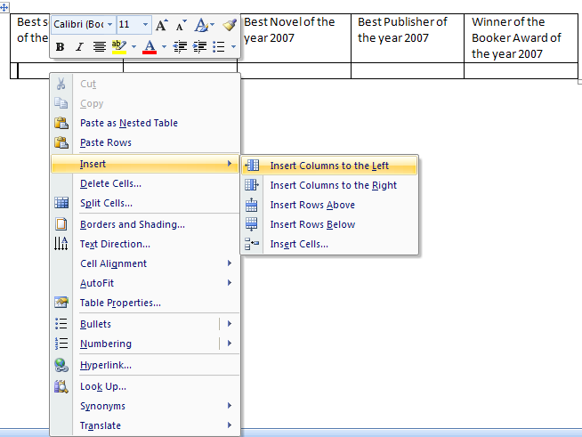

- Deleting Cells / Table can be done by right clicking on the cells
- Table properties like width and height of the rows and columns can be set in the Table Properties option.
  - Right click on the table to go to the table option
- Cell alignment can be done by selecting the Cell Alignment option
  - Right click on the table to go the Cell Alignment
- Word has Built-in table formats to create a quick table

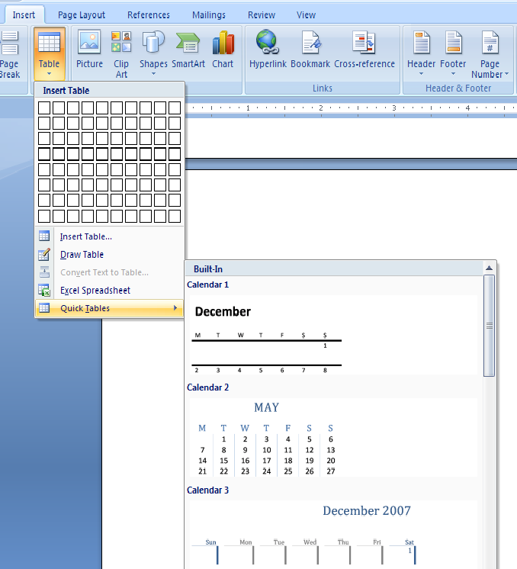
- To merge more than one cell, select the cells to be merged , right click on the table and choose the option Merge Cells
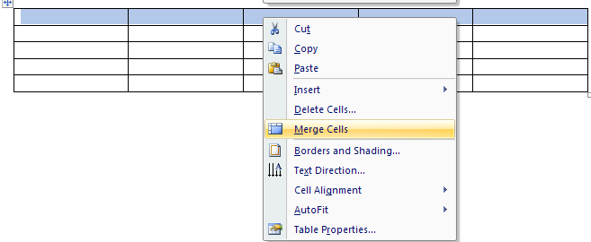

Click here for Assignment → 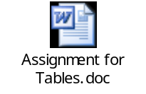

Mail Merge
When you want to send the personalized letter to multiple recipients, you can use Mail Merge option. There is no restriction as to the no. of addresses to ne attached to the letter.

This assignment takes you through the Mail Merge option using the references from MS Excel
- MS Excel file need to be updated with the addresses
- Draft a letter
- Click on Mailings
- Click on Select Recipients and use Existing list 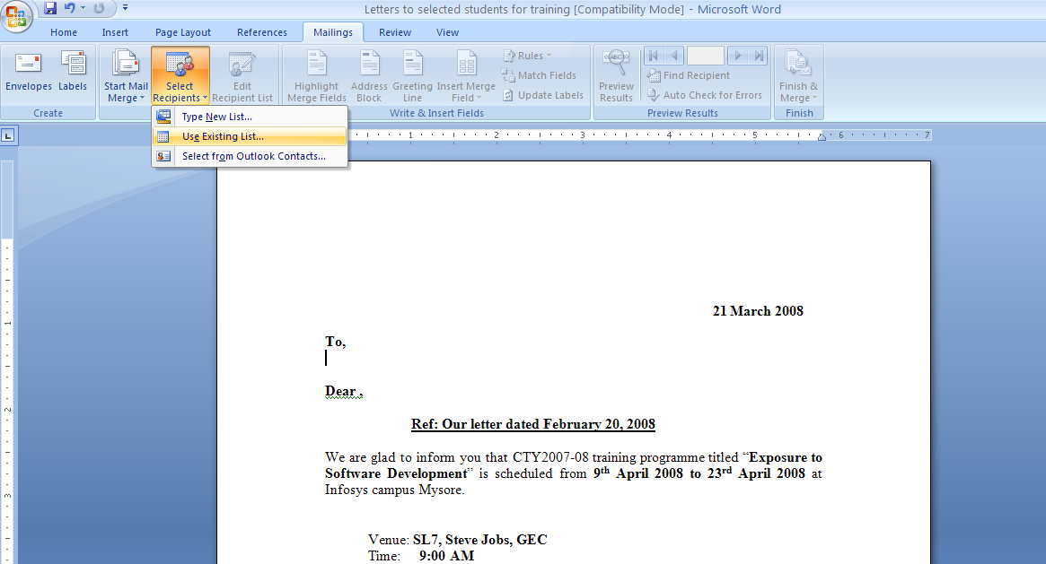

- Select the file from the data source

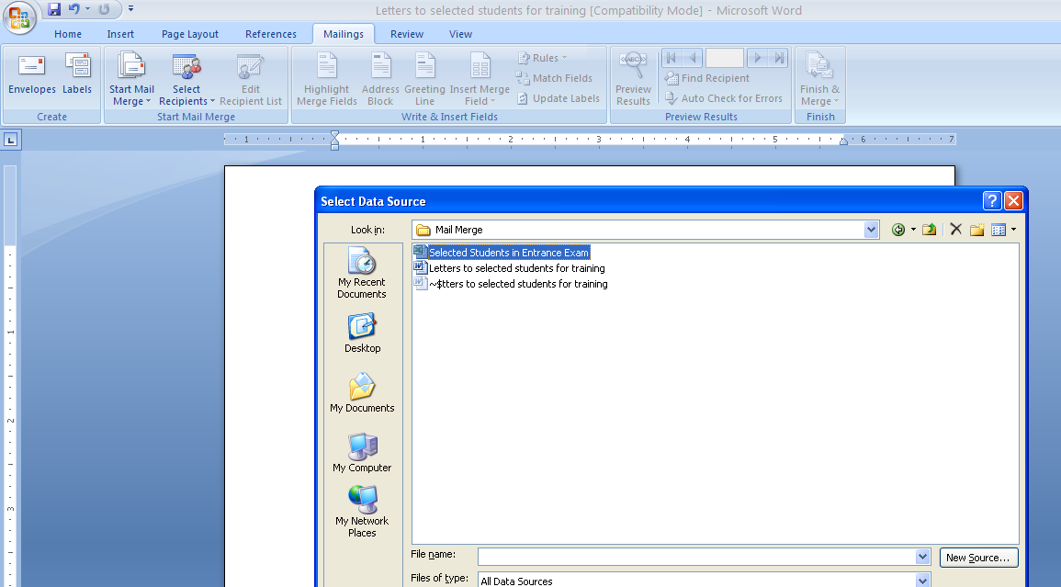

- Select the sheet where addresses are updated and click on OK
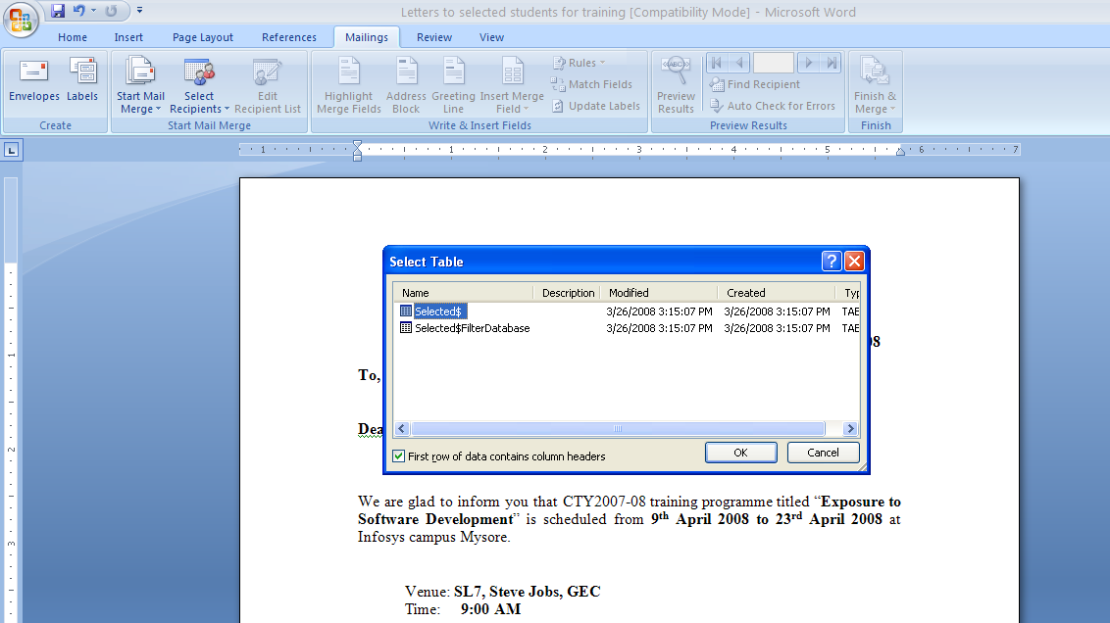

- Insert Merge Fields
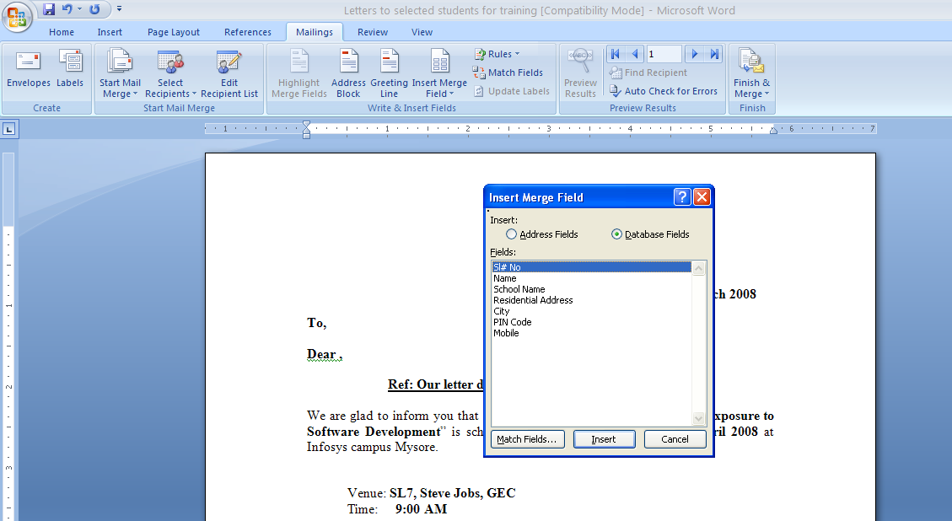

- Preview results
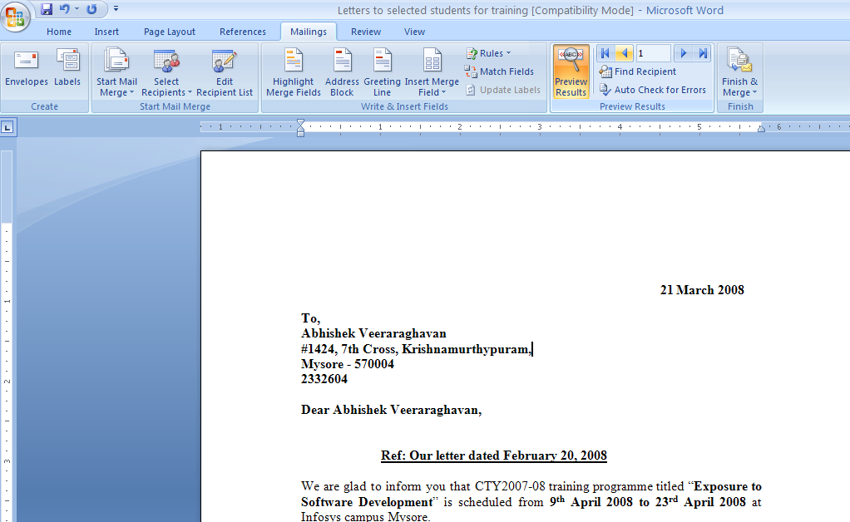

Click here for Assignment → 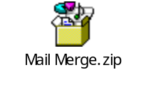

Envelopes and Labels
Create Envelope option in MS Word allows you to create the envelopes when you want to send letters to mass address.

Steps to create Envelopes & Labels

- Click on Mailings
- Click on Envelopes
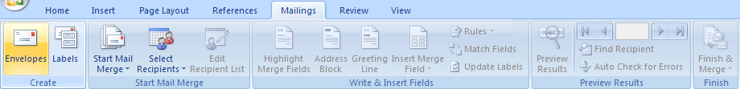
- Enter the addresses (either manually / fetch it from Address book)
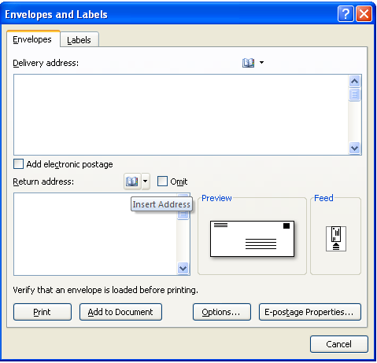

- Envelopes / labels that are created can either be attached to the document or print them directly.

Printing the Word Document
Print option in Word allows you to print the document.
Steps to be followed,
- Click on Office button
- Select Print option
- Select the printer

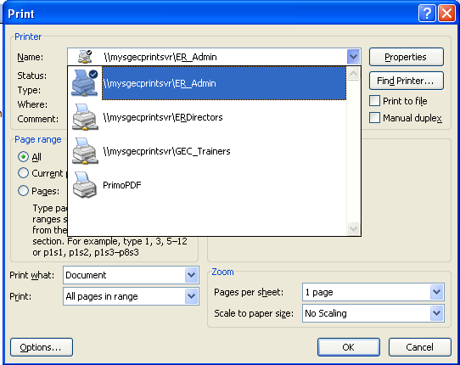

- Choose the print range and No. of copies to be printed
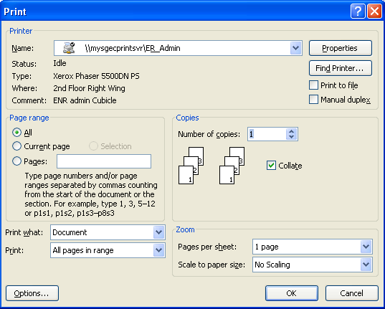

- Click on properties to change the orientation and to enable the duplex mode printing
  - Orientation is the printing layout of the document. Portrait is the vertical appearance and Landscape is horizontal appearance of the document

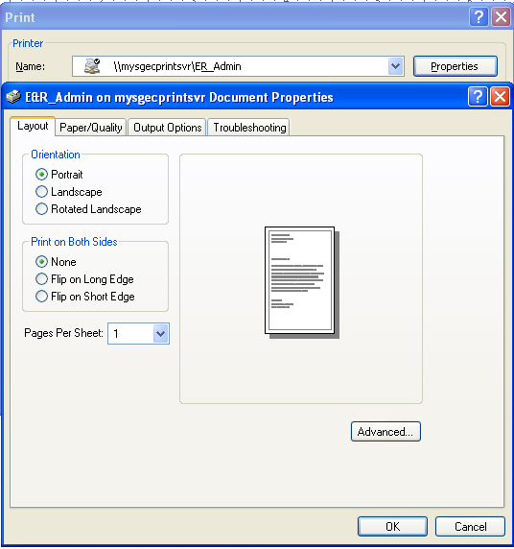

- Click on OK
- Click on Ok to Print

Note:
A document can be previewed before taking the printout by using Print Preview option.

Steps to use Print Preview,
- Click on Office button
- Click on Print option
- Click on Print Preview
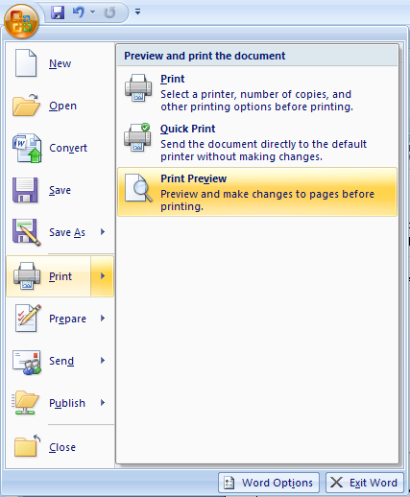

- Click on Close Print Preview to come out this mode
